
 | 2015 | 2016 | Increase
Parent/Caregiver | 29 | 110 | +81
Youth 13-17 | 10 | 63 | +53
Child 7-12 | 3 | 29 | +27
Total | 42 | 202 | +161

Parent Questions | Strongly agree/agree combined | Somewhat agree | Unsure | All disagree combined
The George Hull Centre is friendly and welcoming | 100%
The staff talks to us in a way that is easy to understand | 97% | 3%
It is easy to talk with the staff | 96% | 3%
It is easy to share our views with the staff | 95% | 5%
The staff listen to us | 95% | 1% | 1% | 2%
The staff has the knowledge and skills to help us | 95% | 3% |  | 2%
The staff understands our needs | 92% | 5% |  | 3%
The staff understands our strengths and abilities | 88% | 5% | 3% | 3%
Services are available at a location that is convenient | 87% | 9% |  | 3%
We are learning useful skills | 87% | 10% | 2% | 1%
Services are available at times that are convenient | 85% | 13% |  | 1%
The staff is sensitive to our cultural background | 84% | 3% | 10%
We are better able to deal with our problems | 84% | 12% | 2% | 2%
We are involved in planning our services | 79% | 7% | 7% | 5%
We are getting the services we need | 77% | 12% | 3% | 5%
It is clear what will happen in service | 75% | 18% |  | 5%
Things are improving for my child | 75% | 16% | 6% | 3%
Things are improving for me | 75% | 18% | 5% | 2%
Things are improving for our family | 75% | 14% | 5% | 4%
The staff helps us connect with other services | 71% | 12% | 10% | 4%
The wait to start service was reasonable | 65% | 10% | 2% | 22%

BLITZ 2016
Parents Comments
What was good about the services?
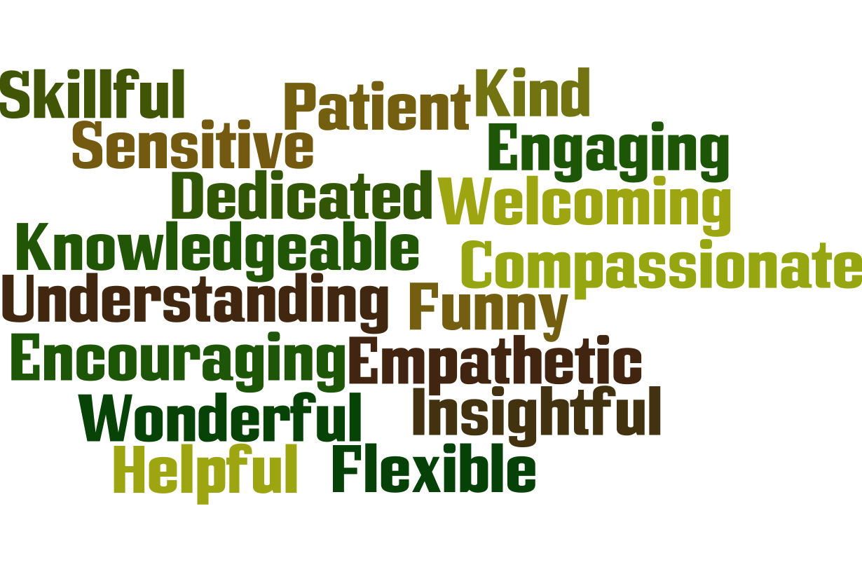

“The staff is patient and understanding. They are there for you and are 100 percent with you until the end.”

“The group for anxiety has changed our lives. The tools we have received as a family have been invaluable…”

“Our counselor is extremely kind, caring and empathetic. She has gone above and beyond for us and we are very grateful.”

“Excellent personal skills and knowledge of relevant information. Clean and friendly environment. It feels like staff go above and beyond their duties.”

“Staff have always been there for me. Staff is very understanding of my situation. My worker has made me stronger and better able to handle things at home.”
“The staff we have interacted with are knowledgeable, accessible and supportive. We were in a real crisis when we arrived and now feel we have a path to recovery. I also really appreciate that our social worker is here for our whole family, not just our son.”
What could make services better?

Waitlist: Reduce wait list -19, More funding -1, more staff -1, Faster access to psychiatry 2
Appointment Times: Evening consultations, evening appointments-3, later hours, more frequent appointments, Available times, Longer sessions, more flex hours for psychiatry
Location - More locations, Closer to subway, Mississauga location
Environment: More space for siblings to play – room, climbing structrueMore time, More heating and cooling
Groups: Guided teaching in group, Smaller groups/more intensive, More content in groups, Time at end of groups for parent networking,
Additional parent groups, More peer group work for kids, Social skills group

Process
Seeking out second opinions when stuck
Written information about services to take home on first visit
More specific screenings and initial appointments - too generic
Have assessments in evening or afternoon so not affect schooling/activities
Make clear what services are available so parents can choose
Explore other strategies when one is not working
More direct observation in psychiatric evaluations less anecdotal evidence
Have family reflect on work and document process and progress for the family
Service integration, group, school, psychiatry
Clear communication on next steps
More open conversation with parents - 2

YOUTH QUESTIONS | Strongly agree/agree combined | Somewhat agree | Unsure | All disagree combined
My worker listens to me | 94% | 2% | 5% | -
The George Hull Centre is friendly and welcoming | 93% | 3% | 2% | 2%
My worker understands my needs | 89% | 5% | 6% | -
It is easy to talk to my worker | 87% | 8% | 3% | 2%
My worker is able to help me | 87% | 5% | 3% | 2%
My worker talks to me in a way that is easy to understand | 87% | 11% | 2%
My worker understands my strengths and abilities | 85% | 10% | 2% | -
It is clear what will happen in service | 85% | 3% | 6% | -
I trust my worker | 83% | 10% | 6% | 2%
It is easy to share my views with my worker | 81% | 14% | 3% | 2%
Overall, I am satisfied with services | 81% | 11% | 2% | 3%
My worker is sensitive to my cultural background | 80% | 5% | 11% | 2%
Services are available at times that are convenient | 78% | 14% | 2% | 5%
Services are available at a location that is convenient | 78% | 11% | 5% | 6%
I am getting the services I need | 76% | 11% | 6% | 2%
I am involved in planning my services | 70% | 16% | 6% | 2%
I am learning useful skills | 68% | 17% | 8% | 2%
The wait to start service with my worker was okay | 68% | 19% | 5% | 7%
My worker helps me connect with other services | 68% | 10% | 14% | 2%
Things are getting better for me | 59% | 13% | 14% | 10%
I am better able to deal with my problems | 56% | 19% | 17% | 5%

What was good about the services?
- Friendly/welcoming
- Safe place, comfortable place
- Worker understanding, compassionate, kind.
- Helpful, useful solutions

YOUTH What could make services better?
- Appointment duration – more often/longer, shorter time, not every week, Shorter time, not every week, More afternoon/evening appts, afterschool weekend
- 2 clients said appointments don’t start on time
- Maybe a not so patient to doctor environment.
- Video games and [……] and candy with pizza, vending machines
- More options other than medication and CBT
- Some requests to be met faster
- help with contacting other services should be explained and approached more thorough
- activities to do
- 2 said more locations
- 3 comments that it was ‘fake’, ‘childish’, ‘unexciting’

BLITZ 2016 Child Questionnaire

 | Strongly Agree | Agree | Not Sure | Disagree | Strongly Disagree | No answer | Total
I like my worker | 23 | 4 | 1 | 1 | . | . | 29
My worker listens to me | 20 | 5 | 3 | 1 | . | . | 29
People at the George Hull Centre are friendly | 19 | 10 | . | . | . | . | 29
My worker is helping me | 15 | 9 | 2 | 1 | 1 | 1 | 29
I am learning things that help me | 13 | 12 | 3 | . | 1 | . | 29
Things are getting better for me | 12 | 8 | 7 | 1 | 1 | . | 29
The George Hull Centre has fun things to do | 11 | 13 | 3 | 2 | . | . | 29
I like coming to George Hull Centre | 11 | 12 | 2 | 1 | 1 | 2 | 29
It is easy to talk with my worker | 11 | 9 | 8 | . | 1 | . | 29
I know what we will do when I come here | 8 | 14 | 5 | 1 | 1 | . | 29

What is the best thing about coming to the George Hull Center?
- Someone to talk to/sympathetic ear/kind - 13
- Fun things/toys/activities -7
- Art - 6
- Friendly welcoming 6
- Friends/people to relate to -4
- Less anxiety 1, help with anger – 1 getting out stress -1, making friends -1, find solutions -1, help our family -1, connecting with family-2
- Safe place 1

What is the one thing that could make it better?
- More time just me and worker- 3 /sessions longer - 1
- more group sessions with other kids
- More exercises, more activities and games, more time with specific toy
- More art
- give adults a snack or a drink because sometimes they have to rush home from work
- Be in more than one place – far to travel
- Making thing to help me
- Waiting room stuff - background music while people are waiting, TV, Games, free wifi, less little kids toys,
more toys and a big area where the kids could play

