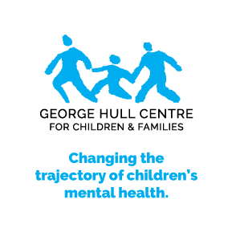**Family Therapy Training Program**

**Virtual via Zoom**

**October 2024 – April 2025**

**Faculty: Reem Abdul Qadir, MSW, RSW**

**Aimee Kenney, MSW, RSW**

**Amanda Chan, MSW, RSW**

The Family Therapy Seminar is a 12-session program that provides in-depth knowledge of theory and practice in family therapy. The program will focus on developing core competencies in assessment, formulation and treatment of families. Aspects of the theory of families and the craft of practice will be taught with the goal of developing an integrative framework.

Emphasis will be given to the development of concrete, applicable skills which participants will have an opportunity to observe with live family work. Observations of live sessions will occur for the duration of the seminar. The seminar will also include required readings, group discussions and experiential exercises.

Participants will learn:

* To complete a comprehensive assessment of a family, develop a formulation and a treatment plan.
* A systemic, 3-generational approach to working with families.
* Theories that inform the intervention with the family such as Structural, Strategic, Relational and Attachment in the context of the family system.
* A basic understanding of brain science, informing how we work with relationships within families.
* To appreciate the diversity of families, e.g. culture, single parent, same sex families.
* The art and skill of questioning in a multi-person system, including using circular versus linear questions and exploring process versus content.
* An understanding of their position of power and social location within a therapeutic setting.
* To explore personal biases to gain an understanding of the underlying values and ethics that we bring into the work.
* To be able to identify patterns in relationships and how these dynamics can perpetuate challenges.
* How to mobilize the strengths of the family to facilitate change in the family system.

Wednesdays, 9:30 a.m. – 1:30 p.m.

October 16, 30, November 13, 27, December 11, 2024

January 8, 22 February 5, 19, March 5, 19, April 2, 2025

**Tuition:**

Registration fee $2,200.00

**Special Early Bird registration fee $1,780.00 if you register on or before September 16th, 2024.**

The George Hull Centre for Children & Families, 81 The East Mall, Toronto, ON M8Z 5W3

**To register or for more information, Contact Reem Abdul Qadir**

**at 416-622-8833 x245 or**

**rabdulqadir@georgehull.on.ca**